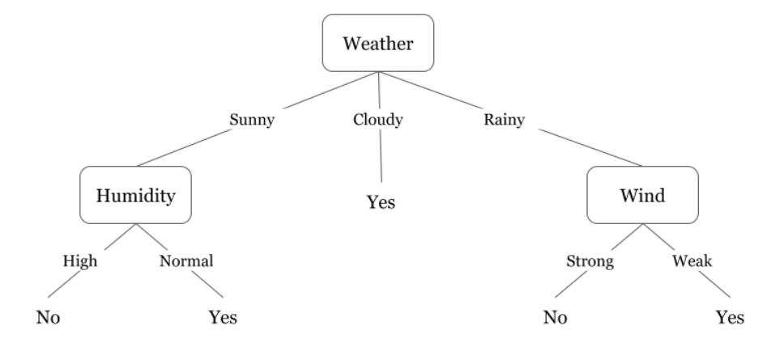

**Entropy**

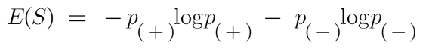

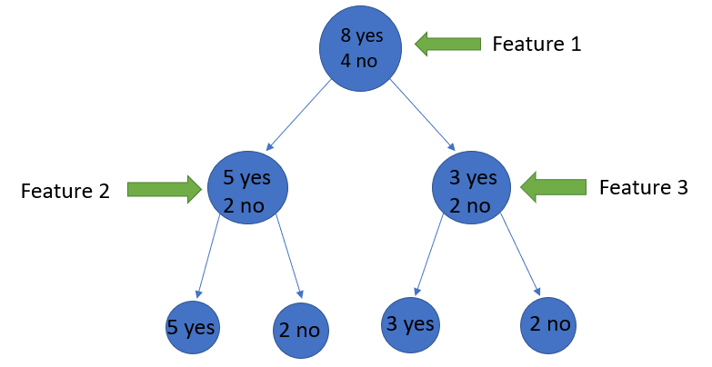

Feature 2 Feature 3

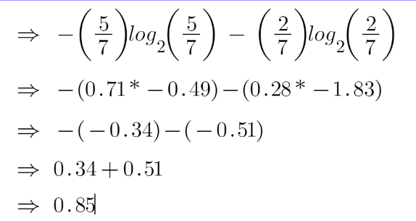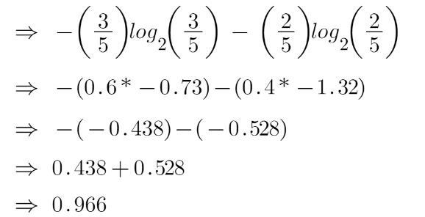

**Information Gain**



